QA TASK: *From* Ring Over

Time starts: 9:49AM, ends: 11:46am

Attendee: Joseph Nirmalraj Jeyanathan

**Legends**:

Questions: Blue

Answers: Black

Part1:

1. What is your opinion on the role of IT Testers and Validation engineers?

* IT testers are known as Software testers, they are responsible for quality of the software development and deployment. IT testers involved in the performance of the manual and automated test to make sure developed software is fit for use.
* Validation engineers also a part of IT testers (same), which means validation is a reactive approach in testing. Validation engineers identify defects and tests are designed to execute after the software has been developed.

1. How would you handle phone call testing and quality?

Have you ever had the opportunity to do this kind of tests?

* For testing the phone call interaction TRAI (telecom regulatory standards) has been launched application which helps to measure the quality of initiating call, waiting moment, transaction, connection and movement with noise.
* Example MyCall Andriod application. Apart from that there are many third party open source app and proprietary app available to test,
* But we have to make sure below terms are enough to monitor from the app provider,

Real time alerts, noise measurement, connect test, voice quality, latency, routing tet, how to trouble shooting methods.

Have you ever had the opportunity to do this kind of tests?

* Yes. For my project in masters.

1. How would you handle testing SQL queries? Have you ever had the opportunity to

do such tests?

* I had experience in development and testing of SQLite Queries for the recent web application in my internship used in python.
* First all engineers have to save the back up of the data base, after testing we have to roll back the same.
* SQL server management studio helps to monitor the all instances of the database,

For testing, MyQuery task can help to boot the data in random row and column.

* I had experience in migration of SQLite to MSSQL database. So total testing and minor development has done by me.

1. How would you handle testing on Mobile apps? Have you ever had

the opportunity to do this kind of tests?

* I have not had an opportunity to test exactly mobile application, instead I have tested my web application and standalone application in Mac and tab with browse r loaded.
* Also, I have theoretical knowledge on how to perform the mobile app testing for the usability and consistency.

1. How will you handle testing on web applications (front-end)? have you already

had the opportunity to do this kind of tests?

* Yes, I had opportunity to test web application by two methods. Graphical user interface and API testing. Front end testing I have performed 70% manual and 30% automation because of application user story scenarios and project timeline.
* I will handle in upcoming project based on the project timeline and criticality of the user stories.
* How much part of manual and automation needed, also to make sure what type of testing is required like functionality, load, stress, regression, sanity,..etc.
* Especially front end testing should cover with cross browser/device functionality for the interoperability.
* Also front end should cover the cases validating by elements include keyboard interpretation, mouse interpretation, button selection, button submission, text enter in forms, validation of get method, send keys method, Style(CSS) patterns, sizes, color standards for each elements, navigation the application.

1. How do you handle testing on API applications? Have you ever had

The opportunity to do this kind of tests?

* Yes, I had to test web application by two methods. Graphical user interface and API testing. Front end and backend.
* Honestly in my recent project I had tried to automate the 30% by selenium python.
* As API to be testing all the business logics, which does not have user interface which is the challenge I had,
* Method I created to input the data to the function where I expect output data based on the function written for the purpose.
* Here, database testing also need to cove along with the API, so I have at least one side view that, I am inputting the data and if its store in dummy database then I agree the response of input validation,
* If the dummy database written the value based on the algorithm written, it validates the output to API. By this way I validated both API and database.

1. Have you ever used CI/CD? If yes, do you specify?

* Yes, Continuous integration and continuous development pipeline I have used for automated testing.
* CI involved in detect changes in legacy code, execute all cases in frequent time, generation of deployment artifacts and its in a loop
* CD invoved in the catch at end of CI process and it deploys all changes done and build to test the environment.
* In short I can say its spiral model of agile, I mean collection and minimize the frequency of far part.

Part2:

1. Propose a test plan for the following feature:

Step 1: Transfer a call

During a call, click on “Transfer” then enter the name of the person to whom you wish

Transfer the call. Select the type of transfer you want to perform: “Direct transfer”,

“Ask first”, “Send to messaging”. Your call is transferred according to the chosen method and ends automatically!

Step 2: Types of transfer

You can choose between 3 types of transfer:

•Direct transfer: in one click, you directly transfer the call in progress to a member of your team.

If you don't answer, you won't be able to resume the call.

• Transfer with confirmation: contact your colleague to check their availability and send them the

Information before transferring the call.

• Transfer to an answering machine: if your colleague is not available or you know he does not want to be disturbed, transfer the call to his answering machine so that your correspondent can leave him a message vocal.

Test plan:

Test plan is a detailed collection of the test strategy, objectives, estimation schedule, deliverables, and resource of the testing,

For above scenario I understand is the user story. I want to answer In two parts,

Test plan and test case

Test plan:

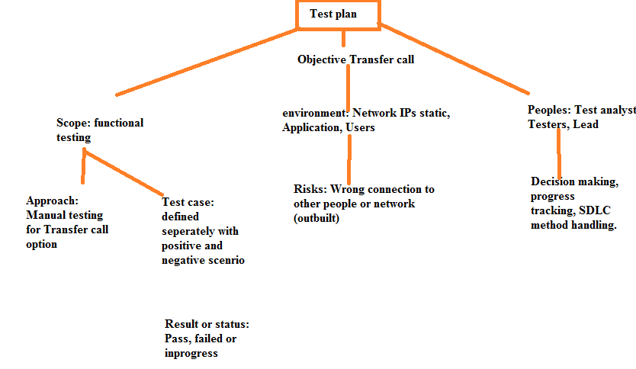

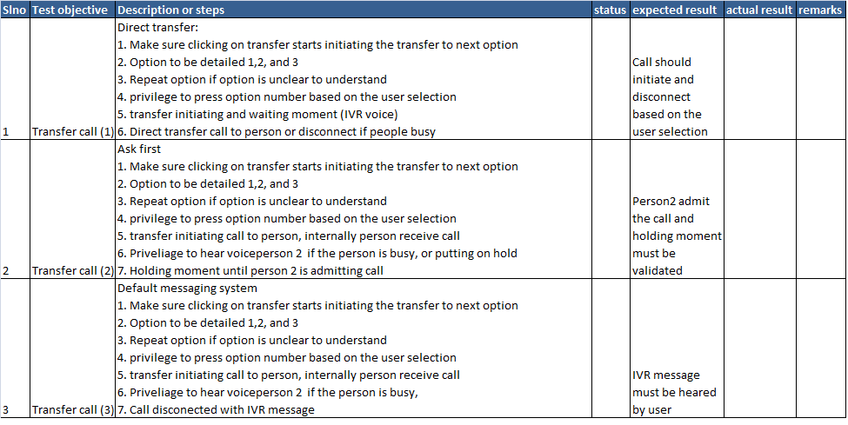

Part 3:

1. Initiate a local GIT repo (no need for git remote ) and perform a commit on each of the

exercise.

<https://github.com/JosephNirmalraj-M/QAtask>

2. Write possible test cases for each method (get, put, post, delete) This solution will be written

in a README.md file and will be added to the git repo.

Test case: REST API

**Get**: Used to extract information from the server given using URL.

<http://URL.com>

**Post**: Used to create a new entity. Also send a data to server and upload data’s

<http://URL.com>

Insert new tab, files. > send button click > server acceptance > update in server.

**Put**: Create a new entity or update existing legacy one

<http://URL.com>

Change old files. > send button click > server acceptance > update in server.

**Delete**: remove all the translation of the target resource given by URL

<http://URL.com>

Target location > delete> confirmation > Click > removed

**3. Automate test cases with an API test automation tool of your choice (Postman,**

**SoapUI, etc).**

Get request:

**Import requests**

[**URL = //http**](URL://http)**....google.maps.com**

**Location = “Paris tour effiel”**

**PARAMS = {‘address, :location’}**

**Req = requests.get(url = URL, params = PARAMS)**

**Data = req.json()**

**Lat = data[1]**

**Longi = data[2]**

**Print(“lat:%s \nLongi: %s \n)**

* **For post testcase:**

**Modification is, below.**

**API_ENDPOINT**

**API_KEY**

**Req = request.post(url = API_ENDPOINT, data = data)**

4. Explain how to perform this solution in the README.md file.

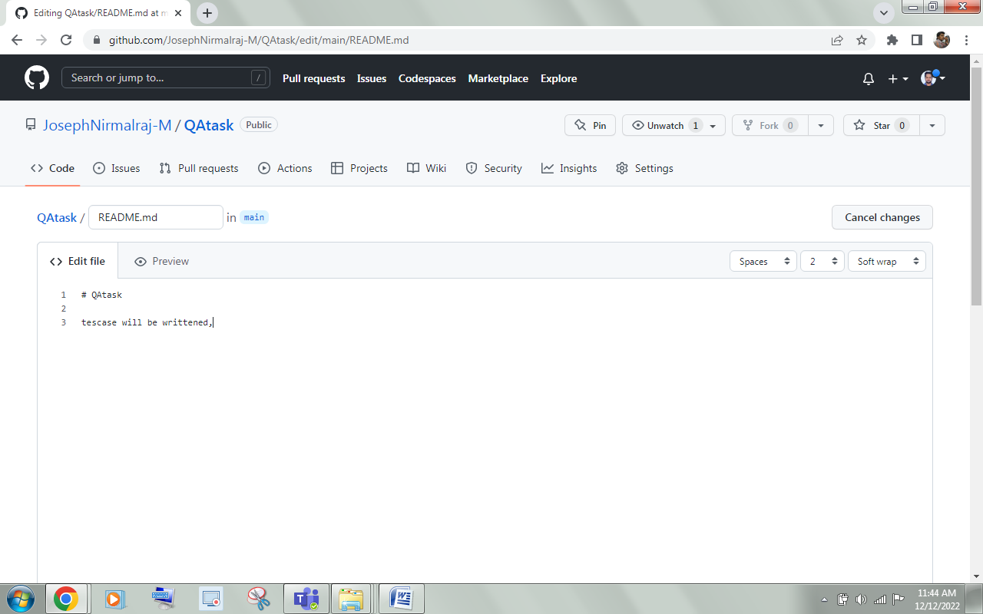

5. Render the exercise in ZIP, TAR or TAR.GZ format.

